6.4 Redox review
Name: ____________________ Class: ____________________ Due date:
1. The equations for two reactions P and Q are given.
P 2NaNO₂ + O₂ → 2 NaNO₃
Q 2HgO → 2 Hg + O₂
In which of these reactions does oxidation of the underlined substance occur?（ ）
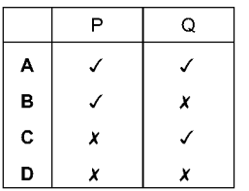

2. The formulae of two compounds of manganese are MnO₂ and KMnO₄.
In these two compounds the oxidation state of potassium is +1 and the oxidation state of oxygen is –2.
What are the oxidation states of manganese in each of these two compounds?（ ）
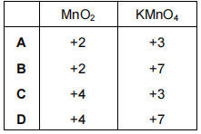

3. Which compound is written with the oxidation state (VII)? （ ）
A CuSO₄
B FeSO₄
C Fe₂(SO₄)₃
D KMnO₄

4. In which equation does the oxidation of the underlined compound occur?（ ）
A 2CuO + C → CO₂ + Cu
B Fe₂O₃ + 3CO→ 2Fe + 3CO₂
C 2Mg + O₂ → 2MgO
D MnO₂ + 4HCl → MnCl₂ + 2H₂O + Cl₂

5. In which change is N₂O₃ oxidised? （ ）
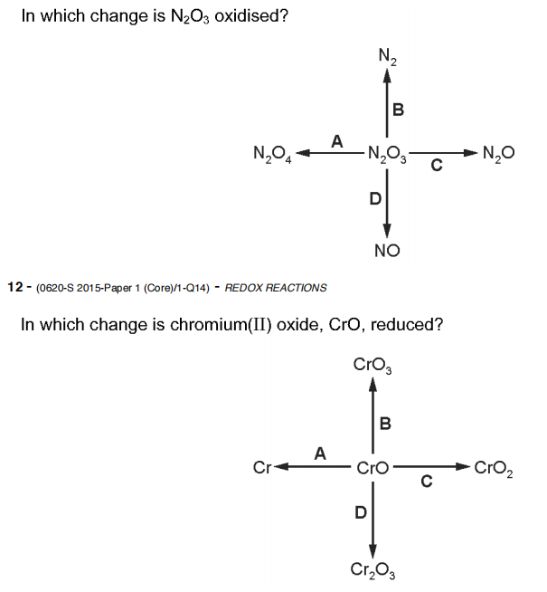
6. In which change is Chromium(ll) oxide, CrO , reduced? （ ）
7. Which change represents an oxidation reaction? （ ）
A chlorine changes to chlorate(I) ions
B chlorine changes to chloride ions
C copper(II) ions change to copper
D potassium manganate(VII) ions change to potassium manganate(VI) ions

8. Which changes represent oxidation? （ ）
1 2I⁻ → I₂ + 2e⁻
2 Cr(VI) → Cr(III)
3 Fe(II) → Fe(III)
A 1 and 2 B 1 and 3 C 1 only D 2 only

9. Which changes represent reduction? （ ）
1 Cl₂ + 2e⁻ → 2Cl⁻
2 Mn(VII) → Mn(II)
3 sulfate(IV) → sulfate(VI)
A 1 and 2 B 1 and 3 C 1 only D 2 only

10. The equations for two reactions of iodide ions are shown.
reaction 1 2 I⁻(aq) + H₂O₂(aq) → I₂(aq) + 2OH⁻(aq)
reaction 2 I⁻(aq) + Ag⁺(aq) → AgI(s)
Which statement is correct? （ ）
A Both reactions are redox reactions.
B Neither reaction is a redox reaction.
C Only reaction 1 is a redox reaction.
D Only reaction 2 is a redox reaction.

11.The equation for the reaction between zinc and aqueous copper(II) sulfate is shown.
Zn + CuSO₄ → ZnSO₄ + Cu
Which statement is correct? （ ）
A The oxidation state of the oxidising agent has changed from 0 to +2.
B The oxidation state of the reducing agent has changed from 0 to +2.
C The oxidation state of the reducing agent has changed from +2 to 0.
D This is not a redox reaction. The solution changes from colourless to blue.
12. Which reaction of hydrochloric acid is a redox reaction? （ ）
A 2Na + 2HCl → 2NaCl + H₂
B Na₂O + 2HCl → 2NaCl + H₂O
C NaOH + HCl → NaCl + H₂O
D Na₂CO₃ + 2HCl → 2NaCl + H₂O + CO₂

13. Substance J takes part in a redox reaction.
In the reaction, J gains electrons.
Which statement is correct? （ ）
A J is the oxidising agent and it is oxidised in the reaction.
B J is the oxidising agent and it is reduced in the reaction.
C J is the reducing agent and it is oxidised in the reaction.
D J is the reducing agent and it is reduced in the reaction.

14. An example of a redox reaction is shown.
Which statement about the reaction is correct? （ ）
A Zn is the oxidising agent and it oxidises Cu₂+.
B Zn is the oxidising agent and it reduces Cu₂+.
C Zn is the reducing agent and it oxidises Cu₂+.
D Zn is the reducing agent and it reduces Cu₂+.

15. The equation for a redox reaction is shown.
2Fe³⁺ + Zn → 2Fe²⁺ + Zn²⁺
Which statements are correct? （ ）
1 Fe³⁺ is reduced to form Fe²⁺.
2 Zn oxidises the Fe³⁺ ions.
3 Fe³⁺ is an oxidising agent.
A 1, 2 and 3 B 1 and 2 only C 1 and 3 only D 2 and 3 only

16. Iodine is extracted from seaweed using acidified hydrogen peroxide, in a redox reaction. The ionic equation for the reaction is:
2I⁻(aq) + H₂O₂(aq) + 2H⁺(aq) →I₂(aq) + 2H₂O(l)
a Give the oxidation number for iodine in seaweed.
b i Is the iodide ion oxidised, or reduced?
ii Write the half - equation for this change.

c In hydrogen peroxide, the oxidation number for hydrogen is +I.
i What is the oxidation number of the oxygen in hydrogen peroxide?
ii How does the oxidation number for oxygen change during the reaction?

iii Copy and complete this half - equation for hydrogen peroxide:
H₂O₂(aq) + 2H⁺(aq) + →2H₂O(l)

17. Displacement reactions occur between metals and metal ions.
Displacement reactions can be used to determine the order of reactivity of metals such as lead (Pb), nickel (Ni), and silver (Ag).
The ionic equation for a displacement reaction is shown.
Ni(s) + Pb²⁺(aq) → Pb(s) + Ni²⁺(aq)
The ionic half - equations for this reaction are shown.
Ni(s) → Ni²⁺(aq) + 2e⁻
Pb²⁺(aq) + 2e⁻ → Pb(s)
The ionic half - equations show that electrons are donated by nickel atoms and accepted by lead ions.
(i) Identify the reducing agent in the displacement reaction. Give a reason for your answer.
reducing agent
reason
(ii) What is the general term given to the type of reaction in which electrons are transferred from one species to another?
(b) The ionic equation for another displacement reaction is shown.
Pb(s) + 2Ag+(aq) → 2Ag(s) + Pb²⁺(aq)
Write the two ionic half - equations for this reaction.
1
2

